CASE STUDY 41

Nested List Classroom Occupancy Analysis
1. Problem Statement
Represent classroom seats as a nested list, preserve reserved seats, assign students to available seats, detect duplicate roll numbers, and calculate vacant capacity.
2. Objectives
Use nested lists to model rows and seats.
Use nested loops and conditions to allocate students.
Count occupied, reserved, and vacant seats.
3. Assumptions
A classroom has a user-entered number of rows and seats per row.
Reserved seats are marked R; available seats are marked ; assigned seats store roll numbers.
A roll number can appear only once.
4. Algorithm
1. Read row and column counts and build a nested list of available seats.
2. Read reserved seat coordinates and mark them R.
3. Read student roll numbers one by one.
4. Reject duplicate roll numbers and place each valid student in the first available seat.
5. Print the seating matrix and counts of occupied, reserved, and vacant seats.
5. Flowchart
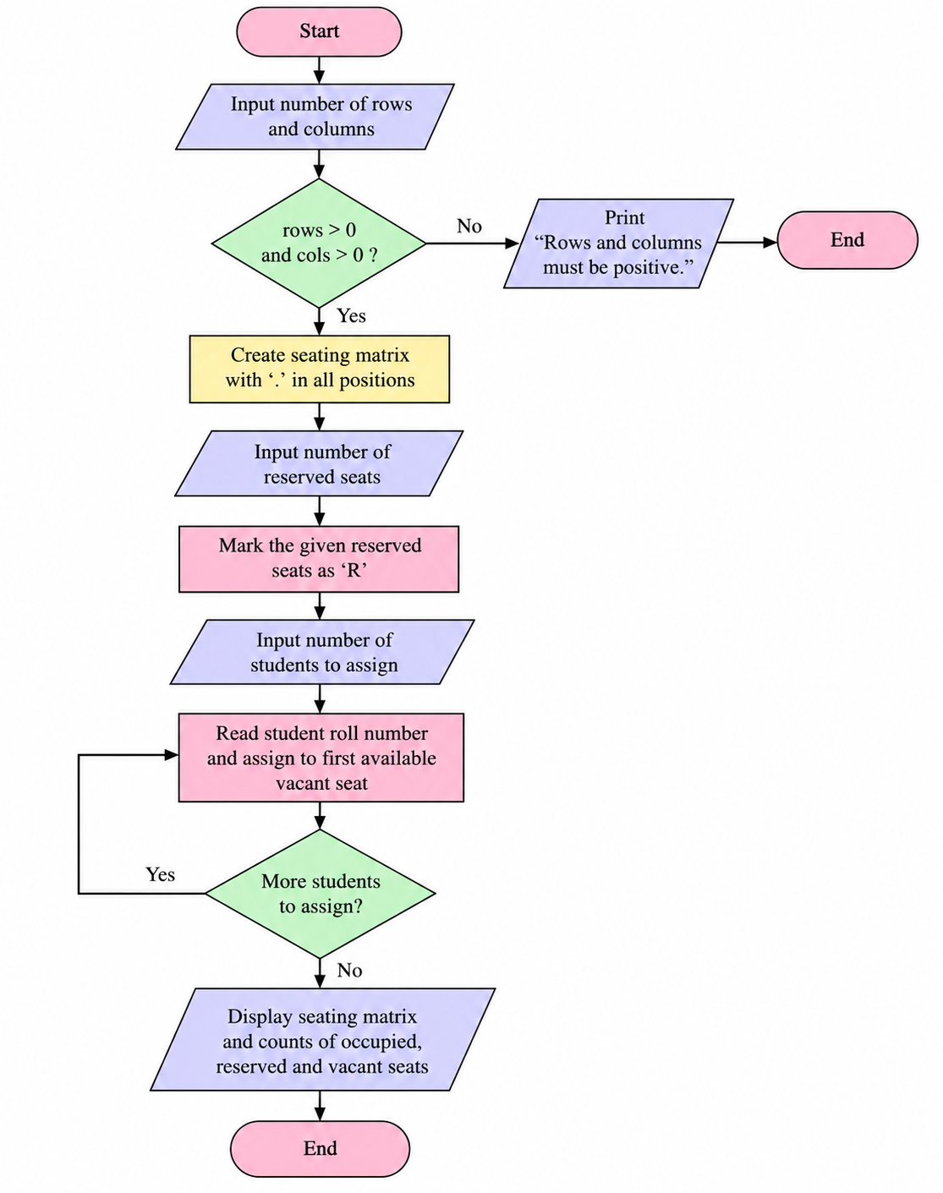
6. Pseudocode
START
INPUT rows, columns
CREATE nested list filled with '.'
MARK reserved coordinates as 'R'
FOR each student roll number:
IF duplicate: reject
ELSE find first '.' and assign roll
PRINT seating matrix and counts
END
7.Test Cases
Test | Input / Scenario | Expected result
1 | fee ₹100; IDs P1,P2,P1; sponsorship ₹500; expenses ₹300 | 2 unique participants; registration income ₹200; total income ₹700; balance ₹400; duplicate P1
2 | no sponsorship and expenses exceed income | Deficit reported
3 | negative expense | Invalid expense rejected
8. Output Screenshot
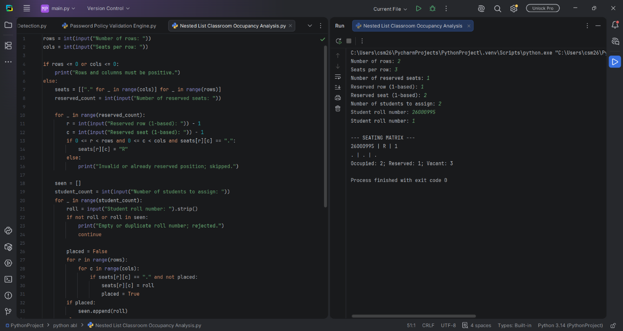
9. Conclusion
The program audits festival finances by counting unique registrations, combining income sources, summing expenses, and reporting the final balance.

